ADULT-ONSET PSEUDOHYPOPARATHYROIDISM PRESENTING WITH TETANY IN ABSCENCE OF ALBRIGHT HEREDITARY OSTEODYSTROPHY: A DIAGNOSTIC CHALLENGE
David George¹, Denis Rayner¹, Silas Frank Gamba¹ and James Masanja¹

¹Department of Internal Medicine, Muhimbili National Hospital, Dar es Salaam, Tanzania
Corresponding author: James Masanja; jamesmasanja@gmail.com

ABSTRACT
Background: Pseudohypoparathyroidism (PHP) comprises a heterogeneous group of disorders characterised by resistance of target tissues to parathyroid hormone (PTH). This results in hypocalcaemia and hyperphosphataemia despite elevated circulating PTH concentrations. Clinical recognition is frequently delayed when characteristic Albright hereditary osteodystrophy (AHO) features are absent, particularly in settings where molecular testing is unavailable. [1,2]

Case presentation: A 43-year-old Tanzanian woman presented with a five-month history of progressive perioral and acral paraesthesia followed by recurrent painful carpopedal spasms, jaw stiffness and generalised tetany. Examination demonstrated neuromuscular hyperexcitability, including positive Chvostek and Trousseau signs, with brisk deep tendon reflexes. She had obesity but no short stature, brachydactyly, round facies or other characteristic features of AHO. Investigations demonstrated profound ionised hypocalcaemia (0.43 mmol/L; reference 1.12–1.32 mmol/L), total calcium 1.9 mmol/L, hyperphosphataemia (1.6 mmol/L) and markedly elevated intact PTH (176.8 pg/mL; reference 6–80 pg/mL), with normal magnesium and preserved renal function. Arterial blood gas analysis excluded respiratory alkalosis as a precipitant of tetany. Computed tomography of the brain showed no intracranial calcification, and renal ultrasonography showed no nephrocalcinosis. A clinical diagnosis of PHP was made on the basis of biochemical evidence of PTH resistance after exclusion of major secondary causes. Symptoms resolved following intravenous calcium gluconate, and treatment was transitioned to oral calcium carbonate and calcitriol.

Conclusion: PHP should be considered in adults with otherwise unexplained hypocalcaemia and hyperphosphataemia, even when AHO features and supportive intracranial imaging findings are absent. With the combination of hypocalcaemia, hyperphosphataemia, elevated PTH and preserved renal function provides a strong biochemical signal of PTH resistance and should prompt appropriate treatment without delaying acute calcium replacement or awaiting molecular confirmation especially in low resource settings. [1,2]

Keywords: Pseudohypoparathyroidism; Hypocalcemia; Tetany; Parathyroid hormone resistance; Trismus; Tanzania

INTRODUCTION
Hypocalcemia has numerous causes, including Pseudohypoparathyroidism (PHP), a rare heterogenous group of disorders characterised by resistance of target tissues to the biological actions of parathyroid hormone (PTH) with a prevalence of around 0.79 per 100,000 according to the Orphaned Report Series, November 2008. The characteristic biochemical profile comprises of hypocalcaemia, hyperphosphataemia, and elevated PTH concentrations despite preserved renal function. Most recognised forms result from genetic or epigenetic abnormalities involving the PTH/PTHrP signalling pathway, particularly the GNAS locus and its downstream signalling components. [1-3]

Clinical presentation is variable; most patients are diagnosed during childhood and exhibit Albright hereditary osteodystrophy (AHO) features such as obesity, round facies, ectopic ossification, brachydactyly, and short stature. Others, particularly those with PHP type 1B, present predominantly with biochemical PTH resistance and few or none of these physical features [1,2] Consequently, adult presentation can be diagnostically challenging, particularly in resource-limited settings where molecular testing is not readily available. [4] We report an adult woman who presented with severe hypocalcaemic tetany and trismus whose biochemical profile established PTH resistance despite the absence of classical AHO features.

CASE PRESENTATION
A 43-year-old Tanzanian woman was referred to our tertiary care facility with progressive neuromuscular symptoms. She had no known chronic medical illness, history of neck surgery or cervical irradiation, or use of medications associated with hypocalcaemia. She denied alcohol or tobacco use, and there was no family history of similar illness.

Approximately five months before admission, she developed gradually progressive paraesthesia and numbness, initially in the perioral region before involving both hands and feet. Over subsequent months, this progressed to painless perioral fasciculations and recurrent, sustained carpopedal spasms that increased in frequency and duration, impairing her ability to hold objects and walk.
On the day before admission, she developed trismus, inability to speak, and generalized tetany, initially raising clinical suspicion of tetanus. However, there was no history of a preceding wound or other features suggestive of an infectious tetanus syndrome.

On examination, the patient was hemodynamically stable and alert. She was obese (Body Mass Index 32.7 kg/m²) but lacked the phenotypic features of Albright hereditary osteodystrophy (AHO): stature was normal, there was no round facies, Archibald's metacarpal sign was negative, indicating absence of brachydactyly, and no subcutaneous ossifications were identified. Neurological examination demonstrated generalized symmetrical hyperreflexia (3+) globally. Chvostek's sign was positive, and inflation of a sphygmomanometer cuff elicited the classical carpopedal spasm (positive Trousseau's sign) (Figure 1).

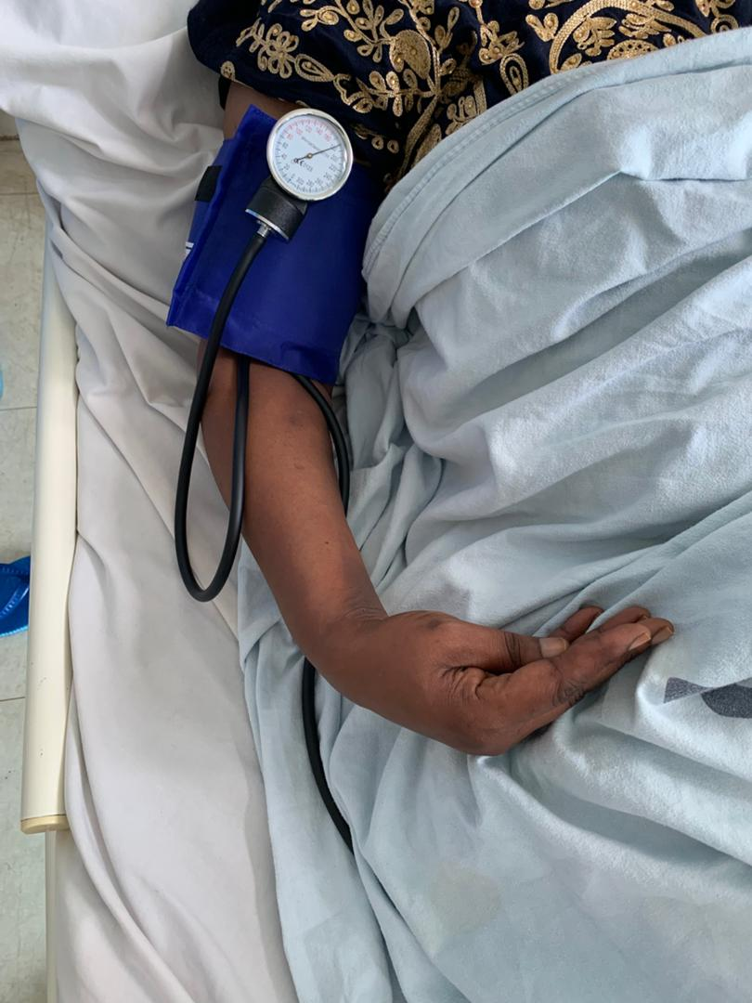

Figure 1. Positive Trousseau’s sign demonstrating carpopedal spasm.

INVESTIGATIONS
Initial laboratory tests showed profound hypocalcaemia, with ionised calcium of 0.43 mmol/L (reference 1.12–1.32 mmol/L) and total serum calcium of 1.9 mmol/L (reference 2.1–2.55 mmol/L). Serum phosphate was elevated at 1.6 mmol/L (reference 0.81–1.45 mmol/L), while magnesium was normal at 1.03 mmol/L. Arterial blood gas analysis showed a pH of 7.41, pCO₂ 36.7 mm Hg and bicarbonate 25 mmol/L, arguing against respiratory alkalosis as a precipitant of tetany.

Intact PTH was markedly elevated at 176.8 pg/mL (reference 6–80 pg/mL) despite severe hypocalcaemia. Serum magnesium was normal at 1.03 mmol/L (reference 0.66–1.07 mmol/L), as were serum albumin (36.1 g/L) and 25-hydroxyvitamin D (37.7 ng/mL). Renal function was preserved, with a creatinine of 53.7 µmol/L. Thyroid and reproductive hormone profiles, liver function tests, HbA1c, and serum glucose were within reference ranges (Table 1). Collectively, these findings did not support common alternative metabolic causes of hypocalcaemia.

Table 1. Electrolytes, Hormonal Assays of Patient on Admission

Electrocardiography (Figure 2) demonstrated sinus tachycardia at 109 beats/min with a QTc interval of 457 ms, consistent with QT prolongation in the setting of severe hypocalcaemia. Echocardiography was normal. Renal ultrasonography demonstrated normal bilateral kidneys without nephrocalcinosis or urolithiasis. Non-contrast CT of the brain demonstrated no basal ganglia or other intracranial calcifications.

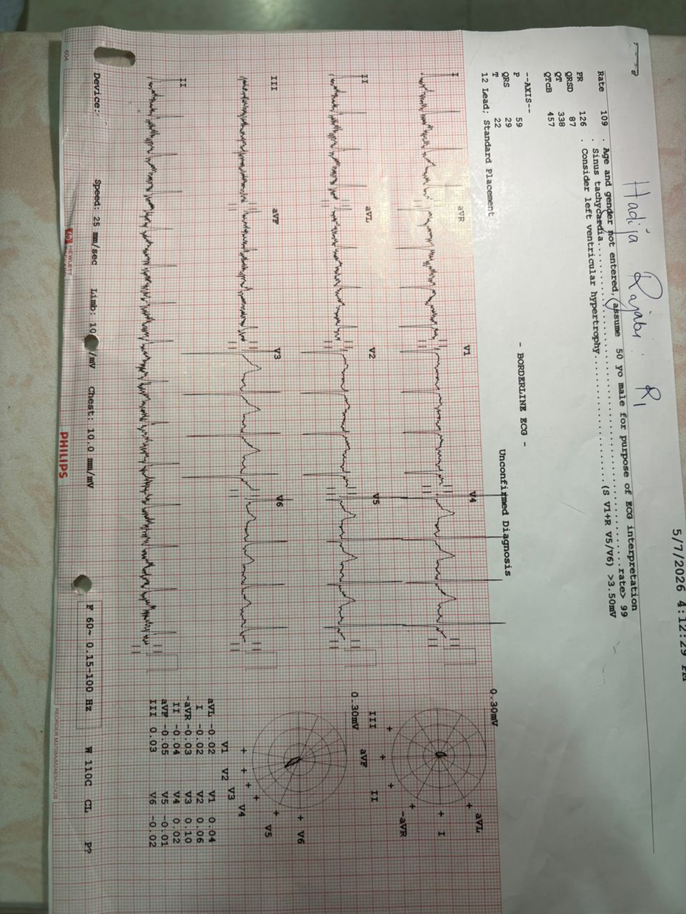
Figure 2. Figure 3. Twelve-lead ECG with a prolonged QTc.
The biochemical combination of hypocalcaemia, hyperphosphataemia and elevated PTH in the setting of preserved renal function strongly supported PTH resistance. [1,2]

DIFFERENTIAL DIAGNOSIS
Primary hypoparathyroidism: Primary hypoparathyroidism was considered because of the profound hypocalcaemia and clinical tetany. It was considered unlikely because PTH was markedly elevated rather than inappropriately low or normal, and there was no history of neck surgery or cervical irradiation. [1,2]

Secondary hyperparathyroidism due to renal disease: Renal secondary hyperparathyroidism was considered but was unlikely because renal function was preserved and creatinine was normal. [1,2]

Vitamin D deficiency or insufficiency: Vitamin D deficiency was considered as a potential contributor to hypocalcaemia; however, the normal 25-hydroxyvitamin D concentration (37.7 ng/mL) made this unlikely. Furthermore, the combination of hyperphosphataemia, markedly elevated PTH, and preserved renal function strongly supported PTH resistance. [2,5,6]

Hypomagnesaemia: Hypomagnesaemia can cause or worsen symptomatic hypocalcaemia and impair PTH secretion or action. In this patient, serum magnesium was normal, making this explanation unlikely.

Respiratory alkalosis: Respiratory alkalosis can reduce ionised calcium and precipitate tetany. However, arterial blood gas analysis showed normal pH and bicarbonate without evidence of alkalosis.

Tetanus: Tetanus was an important clinical mimic because of the prominent trismus and generalised spasms. The progressive perioral and acral paraesthesia preceding the motor symptoms, together with the biochemical abnormalities demonstrating severe hypocalcaemia and PTH resistance, supported a metabolic rather than infectious cause.

Based on the overall clinical and biochemical findings, a clinical diagnosis of pseudohypoparathyroidism was made. The exact molecular subtype could not be established because genetic and functional testing was unavailable.

TREATMENT
Acute symptomatic hypocalcaemia was treated with intravenous calcium gluconate, with repeated 2-g doses until clinical improvement was achieved, resulting in complete resolution of the perioral twitching, jaw stiffness, and carpopedal spasms within 24 hours. Following stabilisation, she was transitioned to oral calcitriol 0.25 µg once daily and calcium carbonate 500 mg twice daily. She also received counselling regarding dietary calcium intake, vitamin D optimisation and the need for long-term monitoring. [1,2]

OUTCOME AND FOLLOW-UP
Once tolerated the transition to oral therapy and was discharged after 5 days of admission in stable clinical condition with planned endocrine follow-up. Genetic testing was recommended for definitive molecular classification and genetic counselling but was unavailable locally because of limited resources. A detailed family history was obtained, and screening of potentially affected relatives revealed no clinical or biochemical features suggestive of PHP. Continued follow-up included monitoring of serum calcium, phosphate, and PTH and assessment for complications of chronic PTH resistance and its treatment. At more than 3 months of follow-up, she remained clinically well and free of recurrent neuromuscular symptoms.

DISCUSSION
Diagnosing rare endocrine diseases like PHP is exceptionally challenging in low-resource settings, where the unavailability of advanced genetic testing and specialized functional assays often leads to underdiagnosis. This case illustrates this complexity of recognising PHP in an adult with severe symptomatic hypocalcaemia but without the characteristic skeletal phenotype traditionally associated with the disorder. PHP is clinically heterogeneous, and the absence of AHO does not exclude PTH resistance. The international consensus recommends that PHP and related disorders be diagnosed primarily from clinical and biochemical characteristics, with molecular testing used to confirm the underlying molecular cause and define the subtype where available. [1,2] The terminology surrounding PHP has also evolved. The broader term inactivating PTH/PTHrP signalling disorder (iPPSD) was proposed to encompass disorders caused by defects within this signalling pathway and to better reflect their molecular heterogeneity. [3]

PTH normally acts through the PTH1 receptor and downstream G-protein signalling pathways to promote renal phosphate excretion, increase distal tubular calcium reabsorption and support renal activation of vitamin D. Impairment of this signalling pathway results in persistent PTH elevation despite hypocalcaemia and hyperphosphataemia. [1,3] The present patient's profoundly low ionised calcium, elevated phosphate and markedly elevated PTH in the absence of renal failure therefore provide strong evidence for PTH resistance.

In this patient, the severe depletion of ionized calcium lowered the threshold potential of voltage-gated sodium channels in peripheral nerves. This precipitated hyperexcitability that manifested sequentially as sensory paresthesia, localized fasciculations, and overt motor tetany, validated clinically by the concurrent presence of both Chvostek's and Trousseau's signs. [7] The trismus-like presentation introduced an important diagnostic challenge because it can resemble tetanus. However, the temporal sequence of paraesthesia preceding recurrent spasms and the biochemical demonstration of severe hypocalcaemia provided a coherent metabolic explanation.

In adults with PHP, AHO may be incompletely expressed, and some patients present predominantly with biochemical abnormalities. [1,2,4] A 2025 case report similarly described an adult with symptomatic hypocalcaemia, hyperphosphataemia and elevated PTH in the absence of several classical AHO features. [4] The present case extends this observation to in our setting. The absence of intracranial calcification is also clinically relevant. Central nervous system calcification is a recognised supportive feature of long-standing disorders of calcium and phosphate metabolism, but it is not required for diagnosis. [1,2] Its absence in this patient reinforces that radiological findings should complement, rather than replace, biochemical assessment.

A further limitation is the lack of molecular confirmation and functional assessment of PTH signalling. These limitations prevent definitive molecular subtyping. Nonetheless, they do not diminish the immediate clinical lesson: severe symptomatic hypocalcaemia accompanied by hyperphosphataemia and elevated PTH with preserved renal function should prompt consideration of PTH resistance even when AHO features and supportive neuroimaging findings are absent.

CONCLUSION
Pseudohypoparathyroidism should be considered in adults presenting with unexplained symptomatic hypocalcaemia and hyperphosphataemia, including those without classical AHO features. Recognition of the characteristic biochemical pattern of PTH resistance can allow timely treatment of severe hypocalcaemia even when molecular testing is unavailable. In resource-limited settings, careful interpretation of calcium, phosphate, PTH, magnesium, vitamin D and renal function may therefore be more important than reliance on phenotype or radiological findings.

LEARNING POINTS
- Severe hypocalcaemia with hyperphosphataemia and elevated PTH in the presence of preserved renal function should raise suspicion for PTH resistance and pseudohypoparathyroidism.
- The absence of classical Albright hereditary osteodystrophy features does not exclude pseudohypoparathyroidism, particularly in adults with predominantly biochemical disease.
- Molecular testing is valuable for confirming the underlying disorder and defining subtype, but acute symptomatic hypocalcaemia should be treated promptly and should not await genetic confirmation. [1,2]

PATIENT CONSENT
Written informed consent was obtained from the patient for publication of this case and accompanying images.

REFERENCES
- Mantovani G, Bastepe M, Monk D, de Sanctis L, Thiele S, Ahmed SF, et al. Diagnosis and management of pseudohypoparathyroidism and related disorders: first international consensus statement. Nat Rev Endocrinol. 2018;14(8):476-500. doi:10.1038/s41574-018-0042-0.
- Mantovani G, Bastepe M, Monk D, de Sanctis L, Thiele S, Ahmed SF, et al. Recommendations for diagnosis and treatment of pseudohypoparathyroidism and related disorders: an updated practical tool for physicians and patients. Horm Res Paediatr. 2020;93(3):182-196. doi:10.1159/000508985.
- Thiele S, Mantovani G, Barlier A, Boldrin V, De Sanctis L, Elli FM, et al. From pseudohypoparathyroidism to inactivating PTH/PTHrP signalling disorder (iPPSD), a novel classification proposed by the EuroPHP network. Eur J Endocrinol. 2016;175(6):P1-P17. doi:10.1530/EJE-16-0107.
- Ebrahim R, Peedika Parambil N, Poolakundan H, Sonibare AD, Poolakundan FJ. Late-onset pseudohypoparathyroidism: a case report. Cureus. 2025;17(9):e93475. doi:10.7759/cureus.93475.
- Akın L, Kurtoğlu S, Yıldız A, Akın MA, Kendirici M. Vitamin D deficiency rickets mimicking pseudohypoparathyroidism. J Clin Res Pediatr Endocrinol. 2010;2(4):173-175. doi:10.4274/jcrpe.v2i4.173.
- Seki T, Yamamoto M, Kimura H, Tsuiki M, Ono M, Miki N, et al. Vitamin D deficiency in two young adults with biochemical findings resembling pseudohypoparathyroidism type I and type II. Endocr J. 2010;57(8):735-744. doi:10.1507/endocrj.K10E-097.
- Cooper MS, Gittoes NJL. Diagnosis and management of hypocalcaemia. BMJ. 2008;336(7656):1298-1302. doi:10.1136/bmj.39582.589433.BE.
- Najim MS, Ali R, Awad MA, Omer AA. Pseudohypoparathyroidism presenting with seizures: a case report and literature review. Intractable Rare Dis Res. 2020;9(3):166-170. doi:10.5582/irdr.2020.03014.
- Gicheru K, Shah MV, Gitau W, Gathua SN. Pseudohypoparathyroidism: a case report. East Afr Med J. 1983;60(11):814-821. PMID: 6671445.

